**/oll0**

**ROBOGAMES 2019**

EVENT NAME: - IARC

*Date: - 24-01-2019*

**Team info**

Team name: Boombot

Team leader’s name: Avinash Kumar

Number of members in the team (max 5): 4

***MEMBERS:***

|  |  |  |  |  |
| --- | --- | --- | --- | --- |
| S.no. | Name | Tech ID | Email ID | Contact no. |
| 1. | Avinash Kumar | 12608 | [avinashkumar2rock@gmail.com](mailto:avinashkumar2rock@gmail.com) | 7071955977 |
| 2. | Vivek shrivastwa | 12085 | [shrivastwavivek44@gmail.com](mailto:shrivastwavivek44@gmail.com) | 6392634784 |
| 3. | Santosh Kumar Pathak | 12412 | [santosh96pathak@gmail.com](mailto:santosh96pathak@gmail.com) | 9795305397 |
| 4. | Abhishek Chaurasia | 12168 | [achaurasia864@gmail.com](mailto:achaurasia864@gmail.com) | 9936158332 |
| 5. |  |  |  |  |

**IMPORTANT NOTES AND GUIDELINES**

* Filling of this form should be taken **seriously** as the selections would be based on the evaluation of this form.
* All the Information and facts provided by you must be **correct**.
* Any information and content which are taken from elsewhere must be given proper reference.
* Your content should be Brief and addition of unnecessary content should be avoided.
* Images should be used wherever you feel appropriate in a sense that it gives a better vision of your content.
* You can attach CAD diagrams, Electronic simulations provide links etc., related to your robot.
* **Any form of plagiarism shall lead to disqualification.**
* Attach the list of components used.
* Abstract must be submitted in .pdf format.
* If you want to attach a video with the abstract then upload your video on youtube/any cloud storage drive and paste the link in abstract.
* **In-case of multiple abstracts the latest shall be considered.**

***Name of abstract file should be: “Robogames: <Team Name> Event Name”***

**Please check our website** [**www.techkriti.org**](http://www.techkriti.org/) **for further updates**

|  |  |
| --- | --- |
| Vishal Kumar | +91-9643776705 |
| Rishabh Goel | +91-9041693552 |
| Abhishek Arya | +91-8009328984 |
| Shirsendhu Samanta | +91-8902474221 |
| Chitransh Bhatia | +91-9879630131 |

**Introduction**

We are team of boombot . Our robot is autonomous and line and wall following its also count the true and false node and show on display. There was priority between two sensor 1st is IR sensor & 2nd ultra-sonic. When line is not found the robot search wall that’s mean the 1st priority will line following respectively 2nd is wall following.

Sensing First of all your robot would have to be able to sense its surroundings. It would do this in ways that are not unsimilar to the way that you sense your surroundings. Giving your robot sensors: sonar sensors and IR sensor will give your robot awareness of its environment.

Movement A robot needs to be able to move around its environment. Whether rolling on wheels, a robot needs to be able to move. To count as a robot either the whole robot moves, like the Sojourner or just parts of the robot moves, like the Canada Arm. Energy A robot needs to be able to power itself.

* **Sensing** First of all your robot would have to be able to sense its surroundings. It would do this in ways that are not unsimilar to the way that you sense your surroundings. Giving your robot sensors: IR ,sensors sonar sensors will give your robot awareness of its environment.
* **Movement** A robot needs to be able to move around its environment. Whether rolling on wheels, a robot needs to be able to move. To count as a robot either the whole robot moves, like the Sojourner or just parts of the robot moves, like the Canada Arm.
* **Energy** A robot needs to be able to power itself. A robot might be solar powered, electrically powered, battery powered. The way your robot gets its energy will depend on what your robot needs to do.
* **Intelligence** A robot needs some kind of "smarts." This is where programming enters the pictures. A programmer is the person who gives the robot its 'smarts.' The robot will have to have some way to receive the program so that it knows what it is to do.

**CONSTRUCTION**

Body of robot will made up of meta. Two wheels and one front wheel.

Using Microcontroller IC ATMega328p on doted PCB and It will program with Arduino nano or Uno through Arduino as ISP or the image will show how to program in

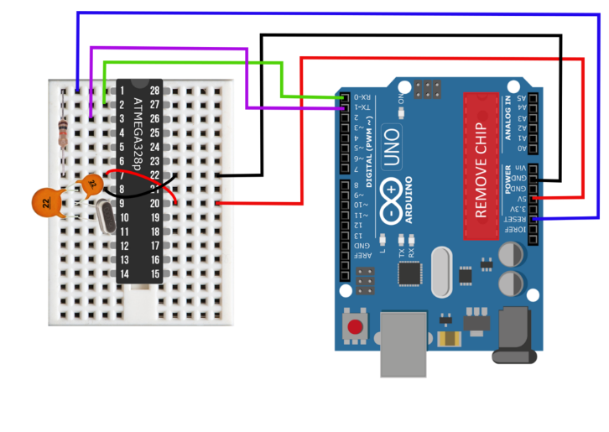

Using LM324 IR sensor (Infrared LED and Photodiode) to detect the line.

And also count the True and False Nodes.

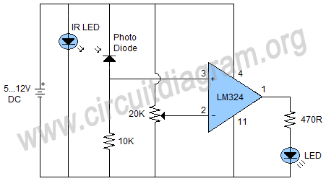

Ultrasonic Sensor will use distance measure.

<https://www.tutorialspoint.com/arduino/arduino_ultrasonic_sensor.htm>

L293D is use to drive two motors. The motor supply is 11.1v and L293D will be supplied by IC 7805 5v. There was two Vcc input in IC ,Vcc1 from the Microcontroller supply and Vcc2 will be separated power supply for the motor. Two motor are connected these are 200RPM motor. There are 4 input line from the Microcontroller and these 4 input basically PWM input in the L293D.

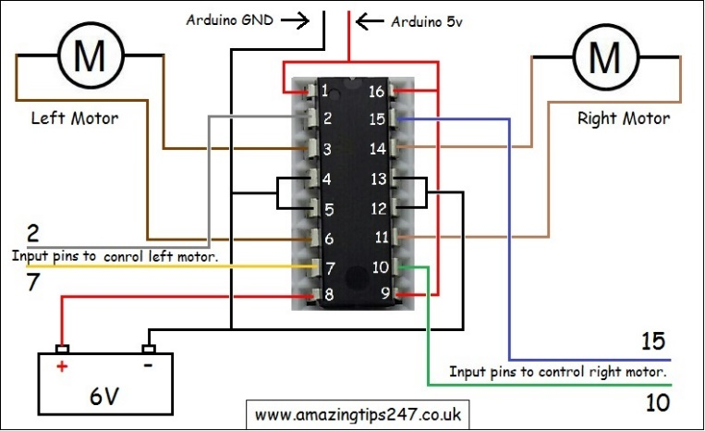

The OLED Display is use to show the block count and there was only 4 line 2 are the power line VCC,GND and 2 are Analog input (SCL to analog pin 0 ,SAD to analog pin 1 in Microcontroller)

There are some resistance , capacitor , wire and 16mhz Crystal to complete the whole circuit

Whole circuit will make on doted PCB

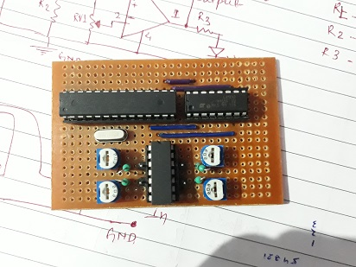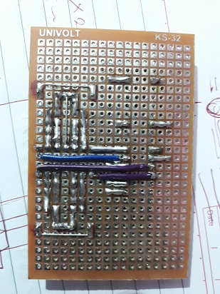

Power Supply is 3 cell lithium ion cell 3.7v *3 = 11.1v and its will directly connected to motor through L293D and 11.1v will converted into 5v by using 7805 IC for supply microcontroller and other part of the robot.

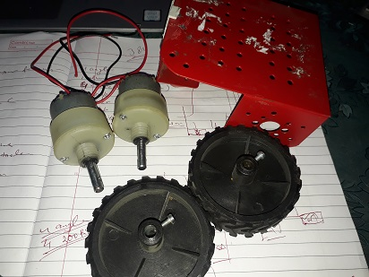

**WORKING PRINCIPLE**

Robot will power by battery and there was two power supply 1st is power microcontroller and 2nd motor to L293D motor driver.

The 1st priority for line following that detect the line and send data to Microcontroller and Microcontroller send instruction to motor driver and motor driver delivery the power to left and right motor as per the sensor. Working principle will show in block diagram 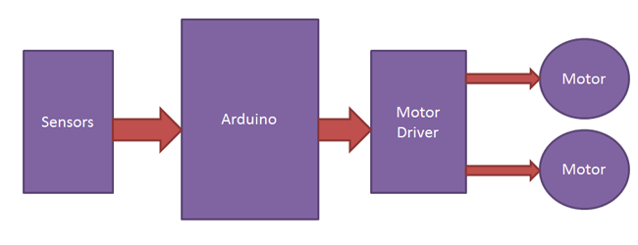

The running logic of line following robot

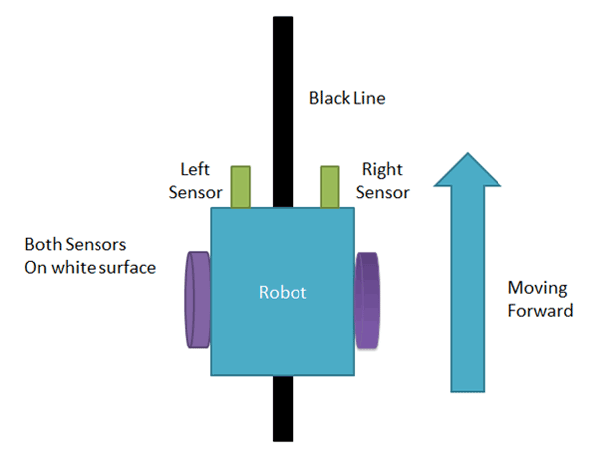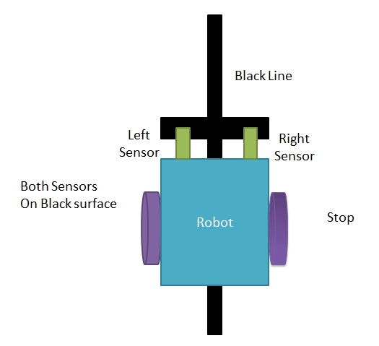

Start and Stop

When both sensor in white surface it will run and the both sensor will on black it will stop.

The turning condition is that one of the sensor is on black line the it will send the response to microcontroller and its diagonal motor will be active.

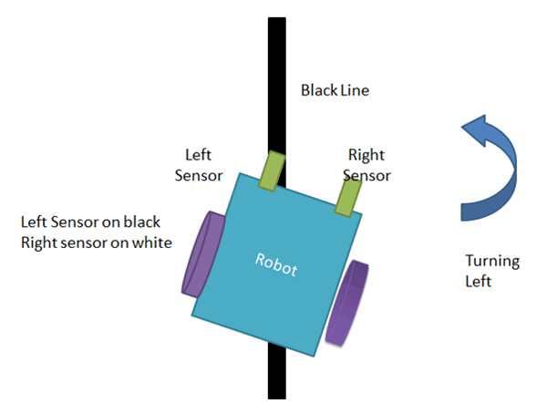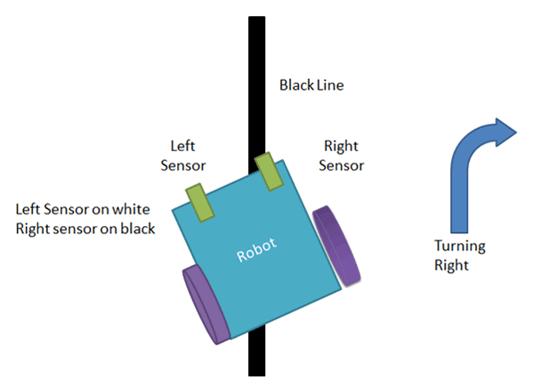

Respectively in the other sensor will work.

TRUE & FALSE node will be count by additional IR sensor and it display on OLED Display which is working on analog to digital. It similarly working on the IR sensor but when the sensor send the instruction 0 and 1 it will added int the count = count +1 and that will show on display.

Ultra-sonic sensor will work on distance measure and similarly it will send the distance to microcontroller as per defined delay time

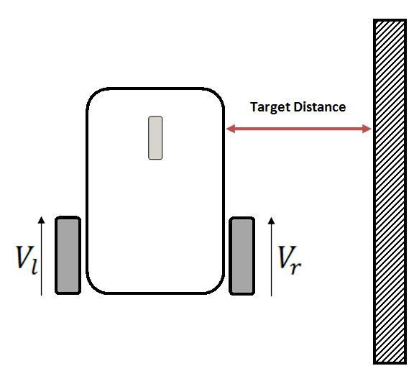

Vl and Vr are two wheel left and right and ultra-sonic place on the top of robot and it target the distance from the robot and similarly working principle of the IR.

The sensor send the distance to microcontroller and microcontroller send to motor driver and it will deliver power to motor.

The image show the rotation and moving of robot with the speed control by program through motor driver

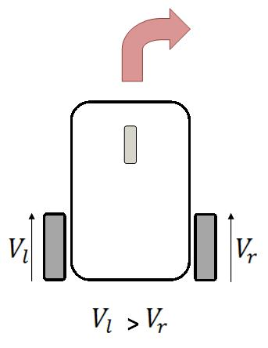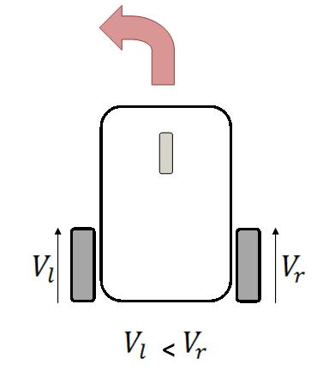

Here is motor Vl > Vr then left motor will run fast and right will show similarly Vl < Vr then right motor will run fast and right.

The distance send in centimeter by return type function and compare the value in a conditional statement if distance is less then 10cm then robot away from the wall and the distance less than 15cm robot come near to the wall if the robot between 10cm to 15cm it will go ahead. The image is show how my robot will run.

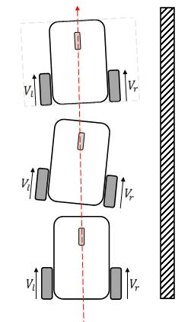

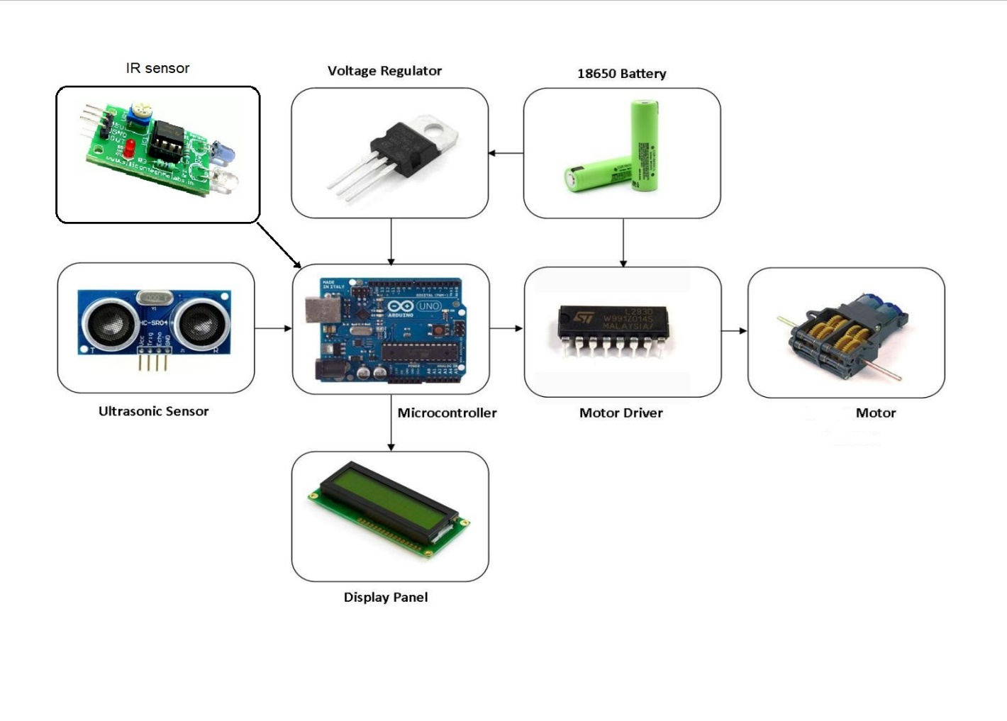

The whole circuit as show in the figure, all component is connected in same manner. In robot there was two sensor 1st IR and 2nd ultra-sonic as per robot there was 1st priority to IR sensor that means 1st it check the line is available the it follow the line if there was no line then ultra-sonic sensor will work and it find the nearest wall with the help of servo or using 3 ultra-sonic and respectively it follow the rule which I already explained.

**References**

(Video links, Github link etc)

|  |
| --- |
| https://www.youtube.com/watch?v=RsDon4NQOs0  https://www.youtube.com/watch?v=SFfYNPrc6c4 |

**Any Information you would like to share**

|  |
| --- |
|  |

(E.g. discuss any other tournament/competition you have participated/win in any institute, etc.)